*Englisch • anglais • inglese*

**Return Assistance at the Federal Asylum Centre**

Return Counselling informs you about Return Assistance. Return Assistance supports you when departing from Switzerland. It helps you starting a new life. Return Counselling is noncommittal and confidential. Return Counselling has no influence on a pending decision on asylum.

**What is Return Assistance all about?**

|  |  |
| --- | --- |
| pikto-bfm-beratung | Counselling |
| pikto-bfm-mediznische hilfe | Medical Aid |
| pikto_bfm_finanzielle starthilfe | Financial Aid |
| pikto-bfm-organisation der heimreise | Organisation of the trip home |

For further information, come and see us

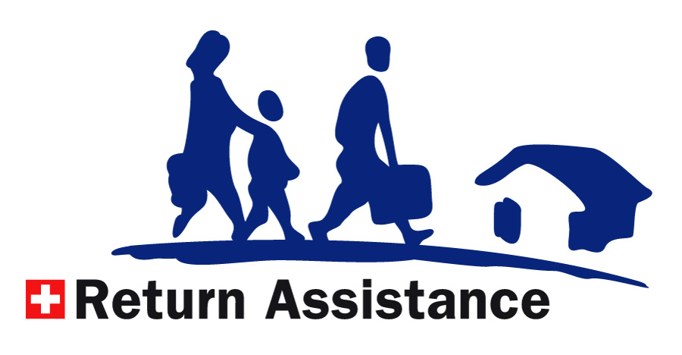at the XXX office / phone XXX