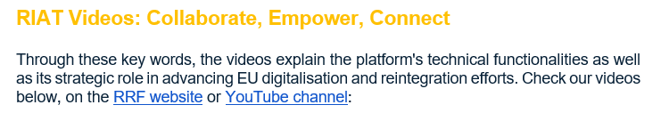

YouTube : Return and Reintegration Facility - YouTube


RRF Website: Reintegration Assistance Tool - Return and Reintegration Facility

