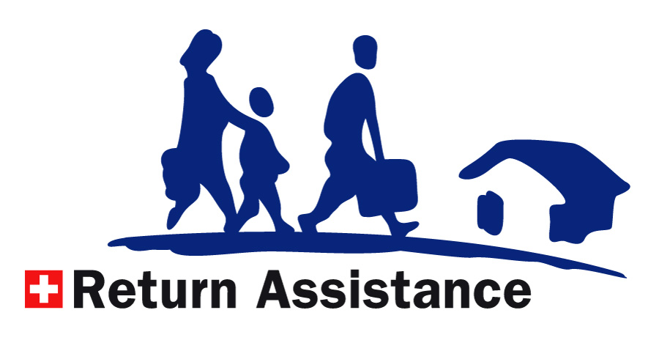
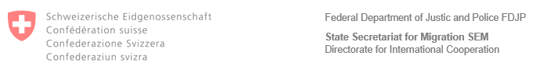

Confirmation of Eligibility and Referral - TÜRKIYE
Your correspondent | [name of return counselling service]
E-mail | [email address of return counselling service]
Phone | [phone number of of return counselling service]
Your reference | [name of beneficiary]
Our reference | [N-Nummer Dossier]

Dear Madam/Sir,
After your arrival in Türkiye, you can contact our local partner YSYD, within a maximum of 6 months after the date of departure, to discuss your options for reintegration support/medical follow-up.
Reintegration Budget:
- Post-arrival assistance: EUR 615 (in cash assistance for first needs after return). Cash assistance is paid in local currency (TRY).
- Post-return assistance: EUR 2,000 (in kind assistance for a reintegration project)
Temporary accommodation, onward transportation, medical needs are deducted from the assistance granted.
Please find their contact details below:
IRARA
YSYD (Association of Assistance Solidarity and Support for Refugees and Asylum Seekers)
Birlik Mahallesi, 411. Sokak, No. 9/2-3
Ankara
Phone: +90 850 455 0000
Email: reintegration@irara.org
Website: hhtps://www.irara.org/turkey
Opening hours: 9am – 6pm (Monday – Friday)

Kind regards,

[insert name and/or signature of return counselling service here]

