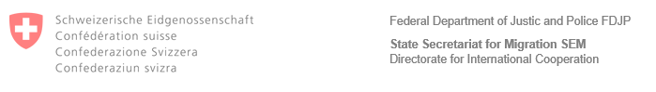

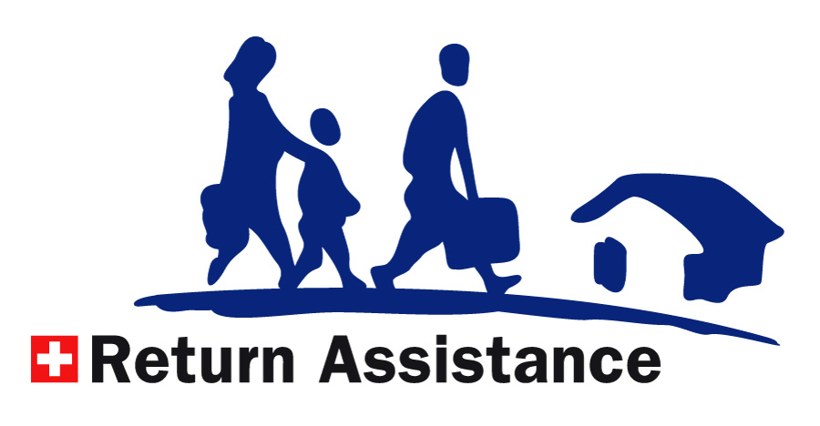

Confirmation of Eligibility and Referral - TÜRKIYE

|  |  |
| --- | --- |
| Your correspondent | *[name of return counselling service]* |
| E-mail | *[email address of return counselling service]* |
| Phone | *[phone number of of return counselling service]* |
| Your reference | *[name of beneficiary]* |
| Our reference | *[N-Nummer Dossier]* |

Dear Madam/Sir,

After your arrival in Türkiye, you can contact our local partner MSYD, within a maximum of 6 months after the date of departure, to discuss your options for reintegration support/medical follow-up.

Please find their contact details below:

**MSYD (Association of Assistance Solidarity and Support for Refugees and Asylum Seekers)**

Birlik Mahallesi, 411.

Sokak, No. 9/2-3

Ankara

Phone: +90 850 455 0000

Email: reintegration@irara.org

Website: hhtps://www.irara.org/turkey

**Opening hours**: Monday – Friday: 09:00 – 18:00 (local time)

Kind regards,

*[insert name and/or signature of return counselling service here]*