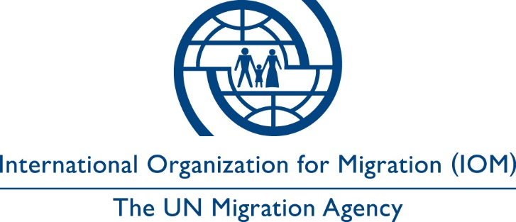

Voluntary return declaration form

NOTE FOR IOM STAFF/PARTNERS:
Each individual who is eligible and is being considered for IOM voluntary return (and reintegration) assistance must be able to understand the content of this form before signing. Please allow the individual to read the form (and ensure it is translated in a language understood by the applicant) and explain its meaning as well as its content before asking him/her to sign it.

I, the undersigned, _________________________________, hereby express my will to return to my home country or a third country (where I am entitled to permanent residence), which is___________________________, through the assistance of the International Organization for Migration (hereinafter IOM).

I confirm that I have been informed about the assistance that I will receive and the conditions of the voluntary return [and reintegration] process, including those specified in the Annex to this declaration.

I understand that the assistance provided under this programme does not include the possibility to remain in any transit country. I understand that I may be interviewed and/or questioned by national authorities upon arrival. I further understand that IOM will not be in a position to interfere with rules and procedures established by airport or immigration authorities in transit or upon arrival.

I acknowledge, for myself and for any person for whom I have the right to do so as well as for relevant heirs and estate, that IOM will not be held liable for any damage caused, directly or indirectly, to me or any such person in connection with IOM assistance that derives from circumstances outside the control of IOM.

I hereby authorize IOM and any authorized person or entity acting on behalf of IOM to collect, use, disclose and dispose of my personal data and, where applicable, the personal data of my dependants [Name of child/family members] for the following purposes:

PURPOSES  Specified and defined prior to data collection | DESCRIPTION | CONSENT
 | To be filled in by data controllers/interviewers | YES | NO
- Assisted voluntary return [and reintegration] | Providing assistance to return voluntarily [and reintegrate] to one’s country of origin.
- Additional assistance | Using data to provide additional assistance under other IOM projects
- Research | Using data for research purpose
- Other | [Please specify]

I agree that my personal data may be disclosed to the following third parties: Swiss authorities (SEM ) and partners to achieve the purpose(s) specified above. I understand that I may access and rectify my personal data on request by contacting IOM.

I declare that I have shared with IOM or its partners all information on any medical condition that may affect my and other persons’ well-being during the voluntary return [and reintegration] process. I also declare that, should the before described information change in the period prior to my departure,I will promptly informIOM or its partners.

I declare that the information I have provided is true and correct to the best of my knowledge. I understand that if I make a false statement in signing this form, IOM may not be able to provide the assistance.

Applicant’s (or legal representative) signature |  | Date and place
Interpreter’s signature [if applicable]: |  | Date and place
Signature of the Representative of IOM or  of the Delegate partner |  | Date and place

ANNEX TO THE VOLUNTARY DECLARATION FORM – Iran

Please be informed that:
- If you have requested airport assistance, you will need to clear immigration and customs formalities first. Once you have passed the exit gate, you will find IOM’s airport assistant near the Information Counter. Please feel free to ask at the Information Counter if you have difficulty locating him.
- After you have arrived in Iran, you should contact IOM’s AVRR Caseworker as soon as possible to set a time to visit the IOM office and discuss your case/plan. The IOM office is open on normal working days from 8.00 to 16.00.
- After meeting with the AVRR Caseworker, you will be requested to complete some forms that will allow IOM to process your request. Please note that it takes at least 10 working days to finalize your case for payment. Your AVRR Caseworker will contact you when your case has been finalized. You are also welcome to contact IOM in Tehran to check on its status during normal working hours
- You will receive your entitlements in IRR at the United Nations (UN) official rate of exchange. The UN rate of exchange is close to Iran’s Official Exchange Rate.

لطفا توجه داشته باشید که:
- در صورتی که برای شما کمک فرودگاهی درخواست شده است، لطفا ساک ارائه شده توسط سازمان بین المللی مهاجرت را طوری حمل نمایید که به راحتی توسط مسئول پذیرش مستقر در فرودگاه، در بدو ورودتان به ایران دیده شود.
- بعد از عبور از درگاه خروجی، نزدیک به قسمت اطلاعات فرودگاه بایستید. در صورتی که مسئول پذیرش مستقر در فرودگاه را در قسمت اطلاعات نیافتید، با شماره موبایل وی تماس بگیرید.
- در اولین فرصت، با مسئول پرونده خود در ساعات و روزهای اداری جهت تعیین وقت ملاقات و گفتگو پیرامون پرونده خود، تماس حاصل فرمایید. جهت تسهیل امور خود، تعیین وقت قبلی به صورت تلفنی الزامی بوده و از مراجعه حضوری بدون هماهنگی قبلی اکیداً خودداری نمایید.
- پس از ارسال موفق، کامل و بدون نقص مدارک، حداقل بعد از 10 روز کاری، مسئول پرونده شما به منظور هماهنگی های لازم جهت پرداخت کمک هزینه با شما تماس خواهد گرفت.
- کمک هزینه در نظر گرفته شده برای شما به واحد پولی رایج در جمهوری اسلامی ایران (ریال) پرداخت خواهد شد که این مبلغ با نرخ تبدیل ارز سازمان ملل متحد محاسبه می گردد. شایان ذکر است که این نرخ، بسیار نزدیک به نرخ دولتی کشور می باشد.

This purpose will need to be defined at the beginning of the project/ signing of the form and can then not be changed anymore.
This row should be removed if not used

