Economic Challenges in the Islamic Republic of Iran in Brief (as of 14/08/2018)

In the wake of heavy sanctions imposed on the Islamic Republic of Iran, it simply cannot stave off recession. Its currency crisis is only getting worse, with the Rial half as strong as it was six years ago and continuing to devalue. Unemployment is around 11 percent. The chart below shows the downward roller coaster ride the Rial has been on during the past six months. As the chart indicates, the official IRR/USD rate is 44,030; whereas, the rate in the free market is on average 112,000.
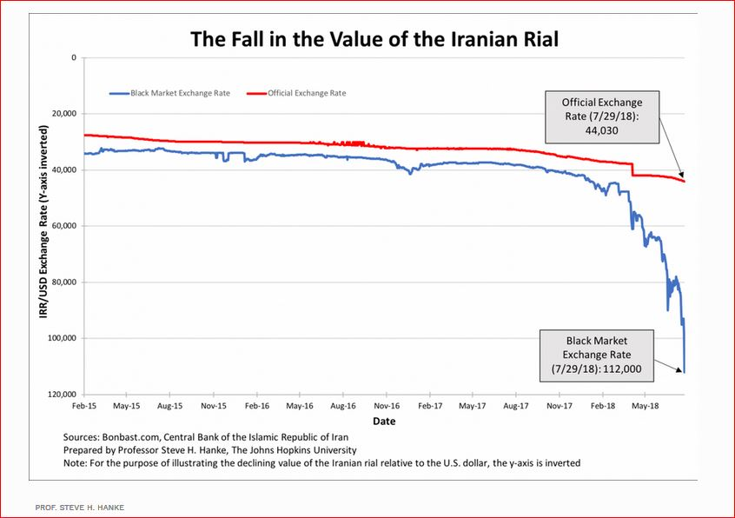

With the collapse of the Rial, inflation has taken off. The chart below shows that picture. Indeed, the free-market exchange rate can be reliably transformed into accurate measurements of countrywide inflation rates. The chart below shows how, with the collapse of the Rial’s value against the U.S. dollar, the Islamic Republic of Iran’s implied annual inflation rate has surged.

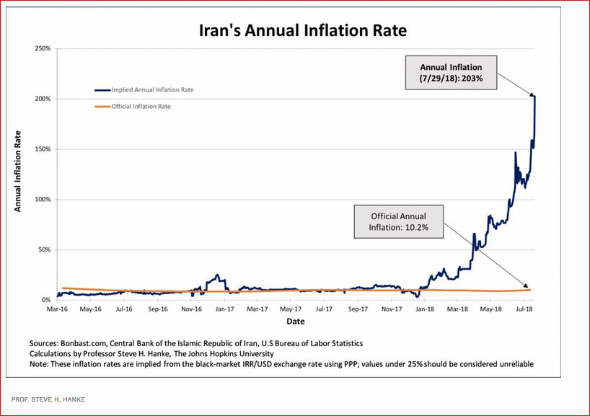

Information provided and designations employed throughout the present brief do not imply the expression of any opinion whatsoever on the part of IOM.

