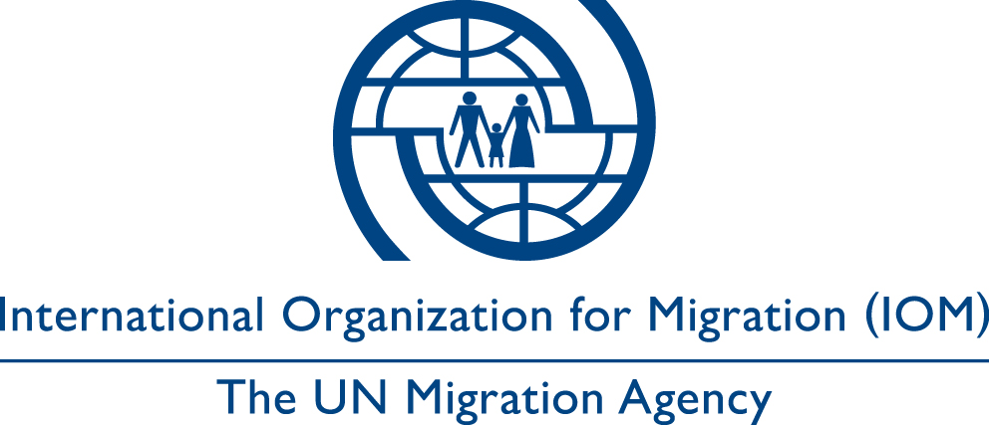

Risk Assessment Form

- Are there any indications of on-going contact between the individual and the traffickers either in the sending or receiving country that would increase the risk factors associated with her/his return and reintegration?

- Does the victim believe him or herself, family members or other loved ones, to be in imminent danger before or after the victim’s return?

- Does the victim show signs of physical or psychological abuse?

- Is the family aware of the victim’s circumstances?

- Is the family likely to react aggressively to the victim?

- Is the trafficking related to a common cultural or traditional practice, such as forced marriage? If yes, may the victims who have been freed from these situations attract social stigma or inspire other anti-social reactions?

- Do the traffickers know the current location of the victim?

- Do the traffickers know the location of the victim’s family or loved ones?

- Are any of her/his family members, loved ones or friends implicated in the trafficking process?

- Is/was the victim in contact with any police authorities in Switzerland?

- Has the victim co-operated with the police? Provided evidence/other

If other, please specify:

- If so, are the traffickers aware of this fact?

- Has the police taken or do they take any action against the traffickers, either in the sending or receiving country, based upon intelligence or evidence provided by the victim?

- Have any suspects been arrested to date?

- Have any suspects been released again?

- Are any of the known suspects still at liberty?

- Are their current whereabouts known?

- Are any suspects based in the receiving country?

- Are the traffickers known to have the capacity (i.e. human or financial resources, contacts, political or social influence) to physically harm or intimidate the victim, and/or the victim’s family members or loved ones, or otherwise compromise the victim’s efforts towards rehabilitation?

- Are the traffickers in a position to have detailed knowledge of IOM’s operational protocols, or those of IOM’s partners that work to provide direct assistance to victims of trafficking?

- Does the victim plan to cooperate with law enforcement authorities in the country of return?

- Does the victim trust law enforcement authorities in the country of return?

- If needed, is the victim aware about specific contacts in the country of return that could help or protect her in case of a security emergency (for example specialized police unit)?

- Does the victim have any specific physical or psychological need or issue that may affect her/his security or may compromise the effectiveness of the security measures to be taken (i.e. regular changes of opinion, drug consumption, dependency, psychiatric disorders, etc.)?

- Are there other factors that would affect the security of the victim?

BELOW PART TO BE FILLED IN BY IOM ONLY

Main risks identified

Specific risk identified | Likelihood and severity

IOM staff final decision based on the risk assessment:

□ No risks or low/minor risks have been identified

□ Medium/Extreme risks have been identified – Need to carry out Risk Management Plan

Risk Management Plan:

The risk management plan may include risks to victim/family/friends/ associations/IOM & partners. It focuses on identified specific risk, timeline, risk level, mitigation action, required resources and responsible actor.

Suggested measures to mitigate the identified risks:

Discussed option with the victim (by FIZ/police, etc.):

Conclusion based on the feedback of the counselor:

Name of the IOM staff member:
Mission:
Date:

Follow-up needed before or after return? □ Yes □ No

If yes, what are the necessary actions?

